**1. V(Accept/Reject/Explore) are calculated correctly – likelihoods match Peter’s calculations**

Likelihood calculation for each subject (using their best-fit parameter values) is the same using my or Peter’s value functions.

Models tested: bjm16_feow for experimental task, bj01 for control task. Values for the winning models are calculated by accessing the same script, so fundamental errors in the winning models are not likely.

|  |  |  |
| --- | --- | --- |
| L using Eleanor’s value function (Experimental) | L using Peter’s value function | Discrepancy |
| 304.82 | 304.82 | 0 |
| 208.20 | 208.20 | 0 |
| 121.50 | 121.50 | 0 |
| 252.63 | 252.63 | 0 |
| 261.26 | 261.26 | 0 |
| 276.12 | 276.12 | 0 |
| 210.15 | 210.15 | 0 |
| 261.33 | 261.33 | 0 |
| 176.49 | 176.49 | 0 |
| 150.32 | 150.32 | 0 |
| 358.61 | 358.61 | 0 |
| 168.82 | 168.82 | 0 |
| 284.44 | 284.44 | 0 |
| 418.31 | 418.31 | 0 |
| 304.38 | 304.38 | 0 |
| 205.32 | 205.32 | 0 |
| 125.55 | 125.55 | 0 |
| 326.25 | 326.25 | 0 |
| 226.80 | 226.80 | 0 |
| 241.72 | 241.72 | 0 |

|  |  |  |
| --- | --- | --- |
| L using Eleanor’s value function  (Control) | L using Peter’s value function | Discrepancy |
| 374.70 | 374.70 | 0 |
| 302.92 | 302.92 | 0 |
| 269.74 | 269.74 | 0 |
| 408.91 | 408.91 | 0 |
| 363.18 | 363.18 | 0 |
| 347.99 | 347.99 | 0 |
| 288.67 | 288.67 | 0 |
| 411.81 | 411.81 | 0 |
| 265.80 | 265.80 | 0 |
| 222.29 | 222.29 | 0 |
| 436.25 | 436.25 | 0 |
| 361.20 | 361.20 | 0 |
| 432.28 | 432.28 | 0 |
| 465.17 | 465.17 | 0 |
| 337.79 | 337.79 | 0 |
| 352.95 | 352.95 | 0 |
| 253.93 | 253.93 | 0 |
| 465.65 | 465.65 | 0 |
| 294.72 | 294.72 | 0 |
| 375.08 | 375.08 | 0 |

Some changes made to Peter’s code: exploration bonuses applied at a different point, V(No See) 🡪 V(Stage 2 Accept) transition different (deterministic), bug in m distortion corrected, j and beta constraints relaxed.

**2. Using the winning models to simulate subjects’ data, and then re-running the fit procedure on simulated data successfully returns similar parameter values**

The fitted parameter values for the winning models (reported in the manuscript) do appear to be reliable. Figure below shows the likelihoods and parameter values from fitting observed (horizontal axis) vs simulated choice (vertical axis). Each data-point is a single subject.

Returned parameter values are mostly similar for each given subject. Likelihoods are similar, though scaled (due to more trials being used for simulated choice).

Experimental task (bpm16_feow)

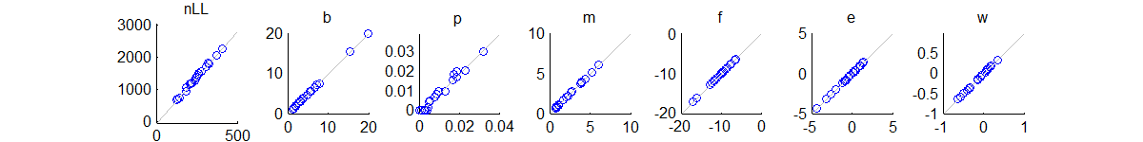

Control task (bpmi11_euw)

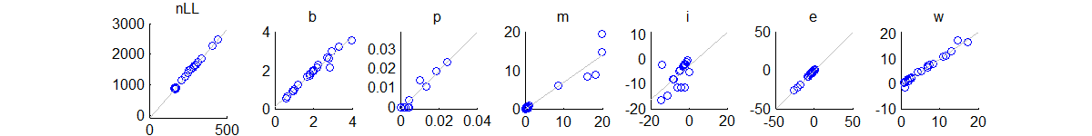

**3. Individual parameters (i.e. their inclusion in the winning model) do not appear to be driven by a minority of subjects. Parameters included in the winning models are also largely in each subjects’ own best model**

Previously, we worried that certain parameters (i.e. their inclusion in the winning model) were driven by a minority of subjects. This appears not to be the case.

I looked at the best-fitting model for each *individual* subject (in terms of BIC), and counted, for each individual *parameter*, the number of subjects whose winning model included this parameter. For all of the parameters that were included in the winning models (highlighted in blue below), these parameters are needed for almost half (or more) of the subjects (N=20, no exclusions). With a minimum subject count of 8 (for winning-model parameters), it seems hard to say that certain parameters are driven by a minority of subjects.

The best-fitting model for most (individual) subjects tended to be high-parameter as well. The mean number of parameters in each subject’s winning model was 5.3 for the experimental task and 4.5 for the control.

|  |  |
| --- | --- |
| **Parameter** | **No .of subjects whose best model includes this parameter (experimental task)** |
| **b** | **20** |
| **p** | **13** |
| j | 9 |
| **m** | **16** |
| i | 7 |
| **f** | **17** |
| **e** | **10** |
| **ow** | **8** |
| uw | 4 |
| vw | 3 |

*Bold = included in group-level winning model*

|  |  |
| --- | --- |
| **Parameter** | **No .of subjects whose best model includes this parameter**  **(control task)** |
| **b** | **20** |
| **p** | **8** |
| j | 5 |
| **m** | **18** |
| **i** | **9** |
| **e** | **15** |
| ow | 1 |
| **uw** | **13** |
| vw | 3 |

*Bold = included in group-level winning model*

**4. There is genuine variability in subjects’ observed choice. But, our models do seem to capture this variability fairly well, and they do reproduce the individual differences in behaviour.**

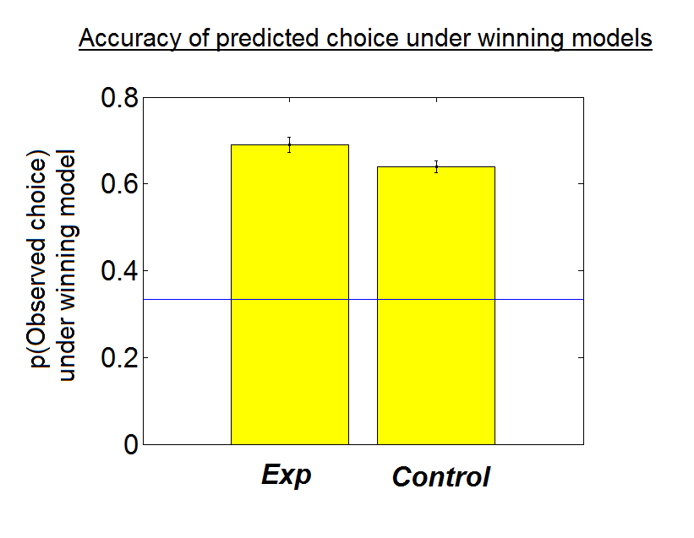 Blue line = chance (1/3)

